**S1:**

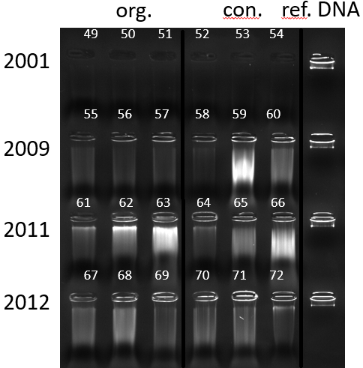

Supplement 1: Gel electophoresis of genomic DNA extracted from stored dry potato tubers. 2001, 2009, 2011, and 2012 indicate the sampling year. Samples were prepared in three field replicates. Left: samples from bio-organic farming (org.), right: samples from conventional farming (con.). Reference DNA (ref. DNA) was extracted from fresh maize leaf tissue. Smear indicate degradation of DNA for example due to storage conditions, or DNA contamination. 2001er samples contain very low amounts of DNA but sufficient enough for low-input library preparation.

**S2:** 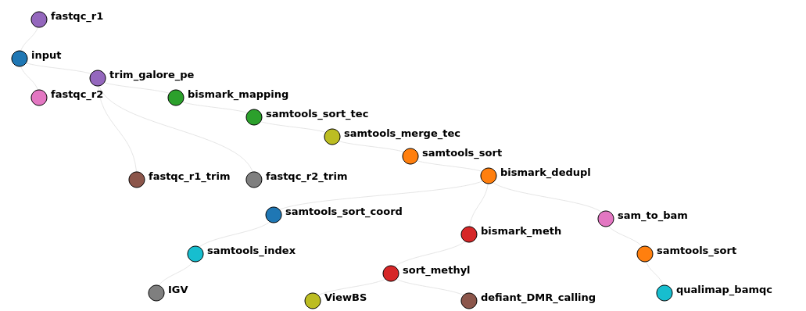

Supplement 2: Bioinformatics Workflow of the Data Analysis Pipeline, each dot represents a specific tool, lines indicate the handover of datasets. The pipeline has been written in Snakemake with anaconda environments on the “IANVS” Cluster of the Martin-Luther University Halle-Wittenberg.

**S3a): HTML-File with the Multi-QC Report, including the number of raw reads as well as mapping rates per pseudo-technical replicate/data set after sequencing**

**S3b): HTML-File with the Multi-QC Report, including M-bias plots per read and C-context**

**S4:** 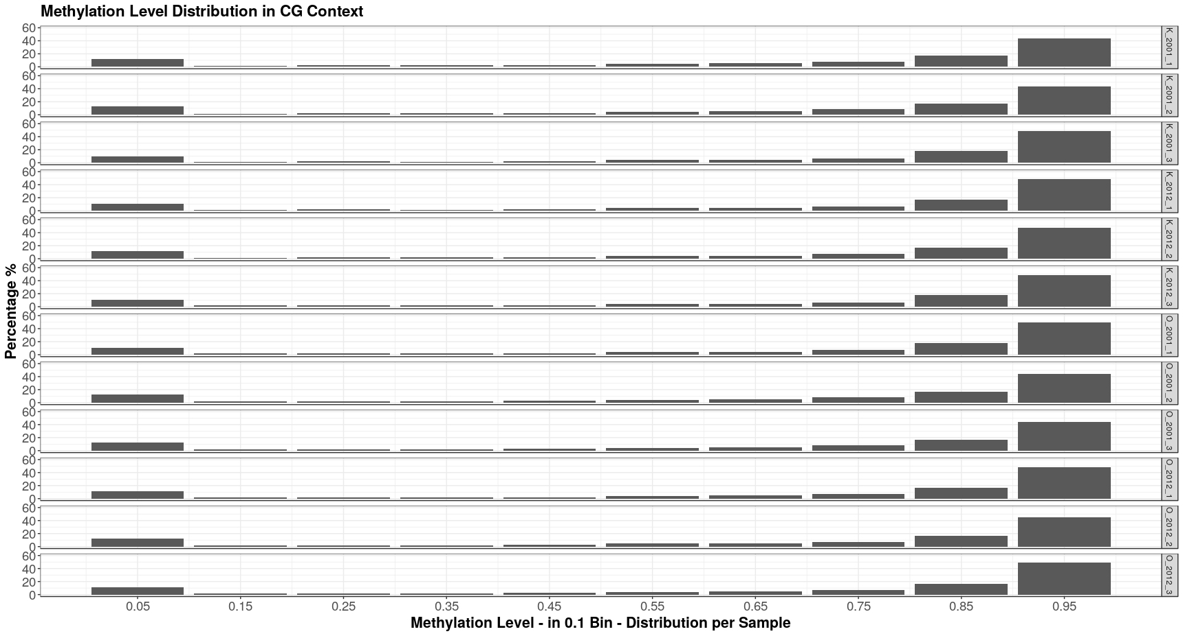

**S5:** 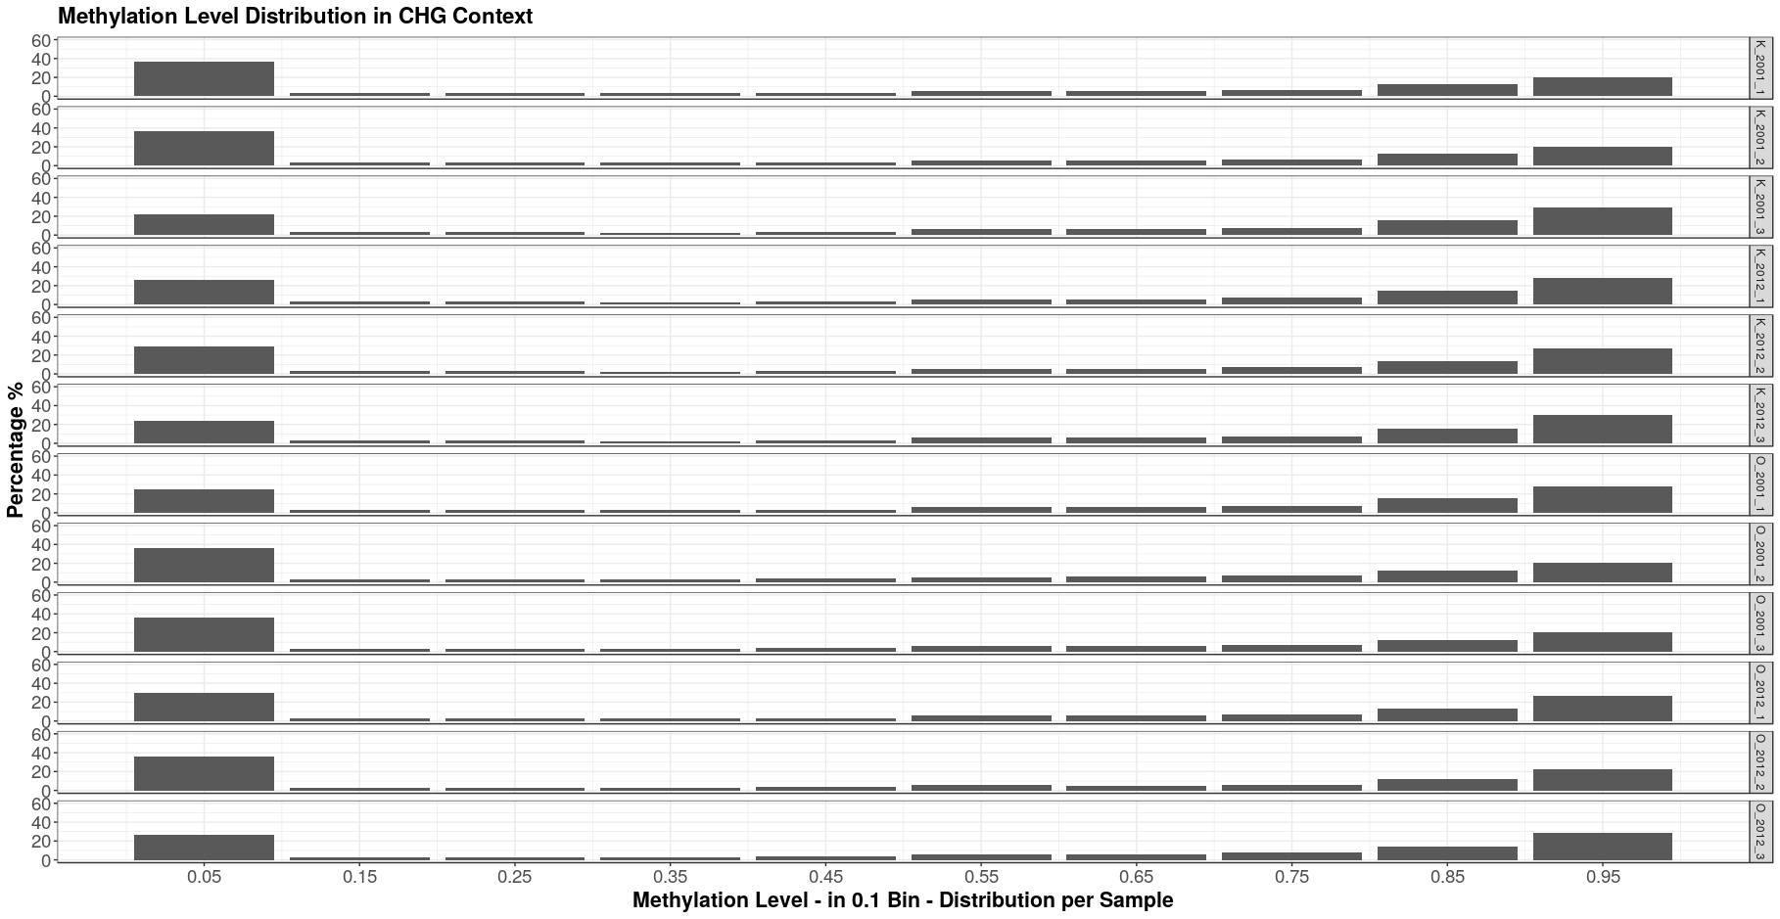

**S6:** 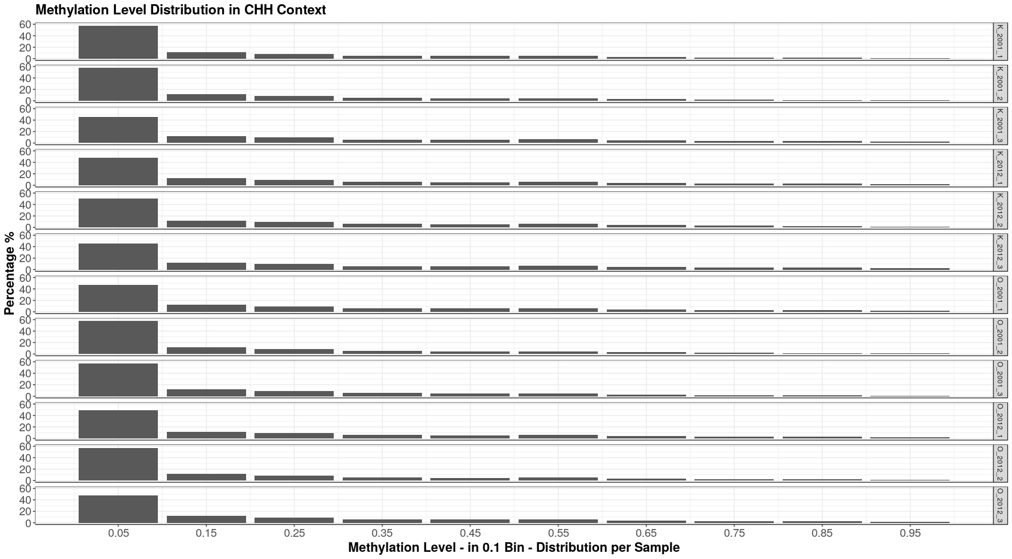

**S7: Chromosome-wise methylation level distribution, exemplary for two samples (K_2001_1 and K_2001_3)**

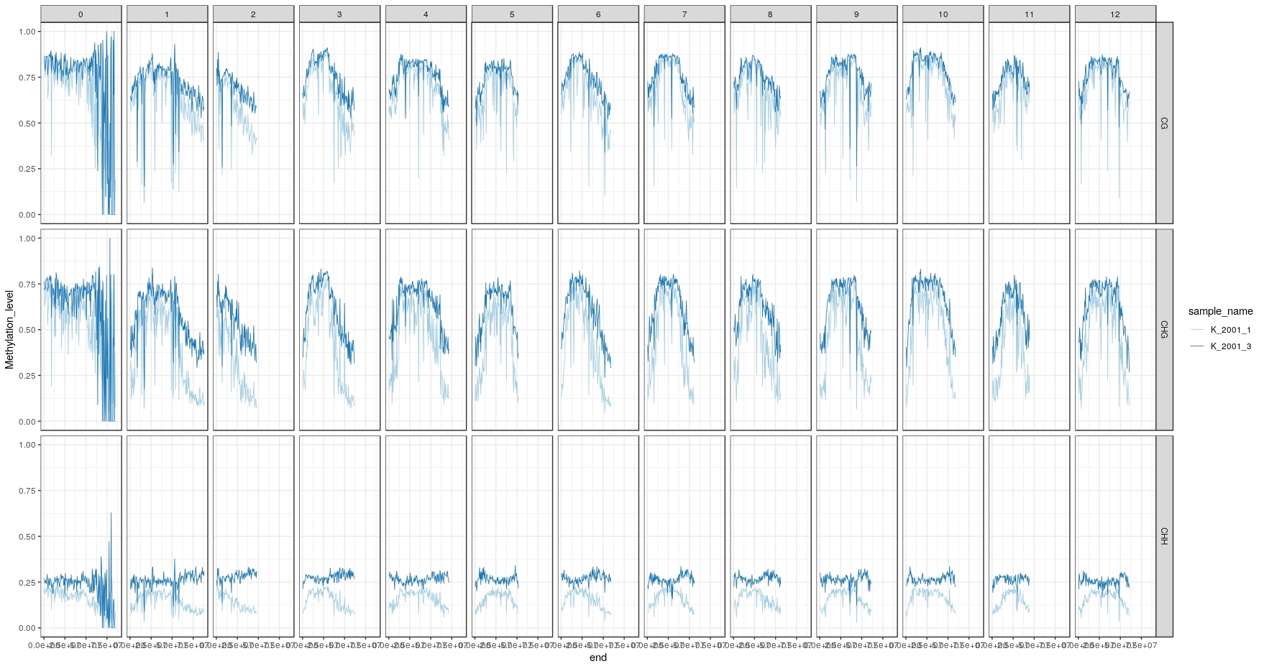

**S8: List of DMRs 2001**

**S9: List of DMRs 2012**

**S10: Overlap of DMC/DMR from 2001 and 2012 (set b & d)**

**S11a-h: GO-term lists for 2001 and 2012 hyper- and hypomethylated regions based on molecular funktion and biological process**